Horse Animation Module 1

# Overview-

The idea is to animate a horse using small sprites and segments, similarly to how it was done in Alien Soldier (link provided for reference)

**Alien Soldier Video**

https://youtu.be/LA03WAjg6ic?t=1815

# Sprites-

I've provided seven sprites, it's just placeholder for now. A broad estimate of where each sprite should connect is indicated with a green cross on each sprite

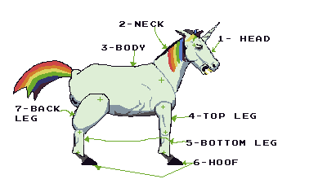

1- Head : Attaches to neck (2)

2- Neck: Attaches to both head(1) and body(3)

3- Body: Attaches to neck (2), the front leg (4), and the back leg (7). One thing I struggled with in putting this module together is how to document the 2 legs that are on the other side/ behind the horse. Apologies for not having a more complete picture on how to address the 2 "behind" legs, but with any luck the animation diagrams should be able to clarify what's needed.

4- Top Leg; Attaches to Bottom Leg (5)

5- Bottom Leg: Attaches to Hoof(6)

7- Back Leg: Attaches to Body (3) and to a copy of the bottom leg (5), which in turn connects to a copy of the hoof (6)

# Animations -

**1- Trot (for phase one)**

Video Reference (from 0:00 - 1:40) for Trot

https://www.youtube.com/watch?v=ziBPaMMUzgM

**Key Frame Guide**

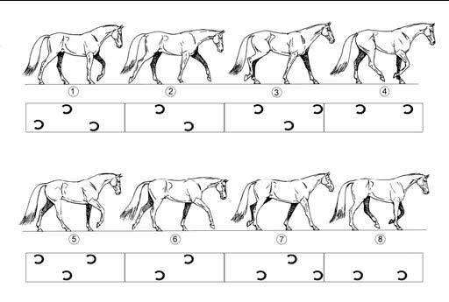

**2- Canter (for phase two, slightly faster than the phase 1 Trot)**

Key Frame Guide

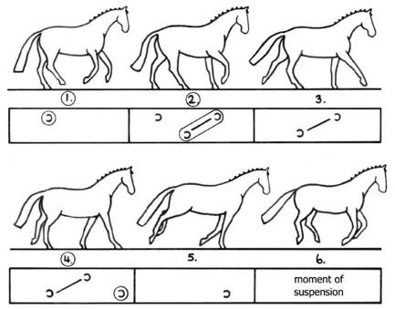

Same video as part 1, but between 1:45 and 3:06

https://youtu.be/ziBPaMMUzgM?t=105

**3- Flying (no walking, just legs tucked in)**

Reference Image

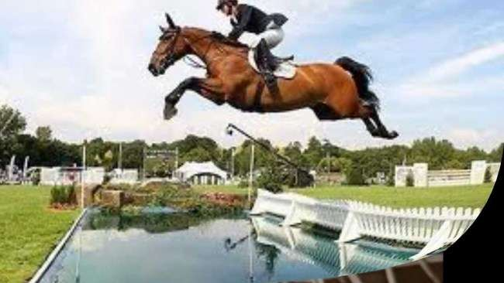

**4- Standing**

This state is only relevant to phases 1 and 2. There will be certain times where the horse should be able to stop walking and stand still (such as transitioning from phase 1 to 2). From this standing position other animations may be needed such as a goring/charging attack which we can address in another module. In short there should be a way for the horse to stop and start as needed, although it should be able to stop and start in a "natural" way rather than having the legs just snap into place. This might be tricky let me know if I'm making sense with this request.

# Wrap Up

So, there's actually a fair amount to tackle with just this first module. One other thing that will probably be needed is a goring/charing animation. Depending on how this all works, it may make sense to create a state where the